#### Armidale Secondary College SDD Yr 11 Assessment 2 Joseph Healy

Developer Documentation- CASE tool

Contents

Client Requirements 1

IPO (Input, Process and Output Diagrams) 1

Context Diagram 2

Data Flow Diagram 2

Gantt chart 3

Log book 3

Test Report 3

# Client Requirements

* Must use a CLI for all user interactions and output.
* Must teach all age groups multiplication and division problems.
* Contains an easy to navigate menu with clear instructions on how to use it.
* Provides a help file included with the application, with said help file being accessible via the application.
* Keeps track of users scores to allow users to see improvement in their attempts.
* Scaling difficulty levels that can be adapted to people who find the questions too easy/hard.
* Must function as intended, even with unexpected inputs.
* The application must communicate all errors clearly to the user.
* All outputs must be intuitive (unless otherwise stated by the application).

# IPO (Input, Process and Output Diagrams)

|  |  |  |
| --- | --- | --- |
| Inputs | Processes | Outputs |
| Game difficulty | Scale problems given based on difficulty.  Increase score multiplier. | Difficulty level set to 1  Difficulty level set to 2  Difficulty level set to 3  Difficulty level set to 4  Difficulty level set to 5  Difficulty level set to 6  Difficulty level set to 7 |
| Menu Input | Navigating to appropriate menu.  Change settings.  Saving and Loading Files.  Exiting. | User interface.  Help file.  Highscore file. |
| Problem type | Change to selected problem type | Problems will be: Division.  Multiplication.  Mixed. |
| User Game Input | Compare against answer.  Change score based on answers.  Start timer from first input.  Stop timer from last input. | “Your answer wasn’t correct, please try again.”  “Unfortunately, that isn’t the correct answer, try again!”  “Incorrect! Please try again.”  “Correct! Well done, onto the next problem”  “Congratulations, that is the correct answer!”  “You answer was correct, onto the next one!”  “You’ve reached the end! Your score is [score]. Going back to menu in 5 seconds..” |
| Request a Generated Problem | Generate a problem based on problem type.  Assign an answer.  Assign score the problem is worth. | Generated Problem. |

# Context Diagram

# Data Flow Diagram

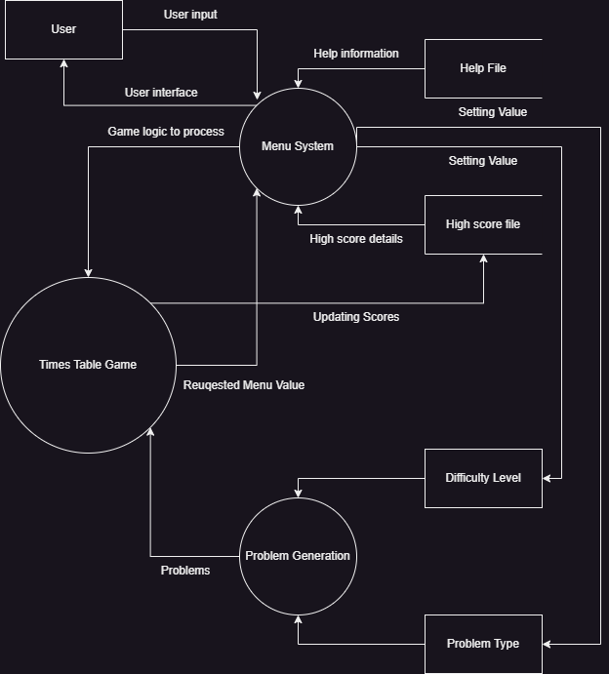

# Gantt chart

# Log book

[See page 22 SDD course specifications](https://www.educationstandards.nsw.edu.au/wps/wcm/connect/44325629-51c6-4330-8bf8-662d5cfbe5fb/software-design-development-course-specs.pdf?MOD=AJPERES&CVID)

|  |  |  |  |  |
| --- | --- | --- | --- | --- |
| Date /Time | Description of progress | Tasks achieved | Issues- stumbling blocks | references |
| 24/7/23 | On this day I finished my Client Requirements, I also started to consider what Inputs, Processes and Outputs my game would possess. | Client Requirements filled  Log Book Started.  IPO Chart Started. | I found a bit of difficulty trying to come up with some client requirements, until I remembered that my TAFE course had a unit last term that covered client requirements. This help me immensely with creating the client requirements. | None used for this day. |
| 25/7/23 | Today I Finished even more documentation. This time I hope that it doesn’t let me down like my last task. Both my context and data flow diagrams were completed today. | Context Diagram completed.  Data Flow Diagram completed.  Research on Gantt Charts.  Started my Gantt Chart. | The context diagram was easy, and I had no issues with it, however the data flow diagram gave me some troubles. I couldn’t remember a few of the symbols, so to remedy this I took a look at the SDD course specs to get a refresh on data flow diagrams. | [Software Design and Development Course Specifications (educationstandards.nsw.edu.au)](https://www.educationstandards.nsw.edu.au/wps/wcm/connect/44325629-51c6-4330-8bf8-662d5cfbe5fb/software-design-development-course-specs.pdf?MOD=AJPERES&CVID) |
| 27/7/23 | Today marked the day I started coding the high score system, All of my documentation has been completed in previous days so now it is time to have fun with coding. | High score system started. | Loading and saving files. During coding of this system the names weren’t saving below each other, this was solved by including the append parameter in the open() function.  Sorting was also another headache, I couldn’t find out how to grab both the name and score and sort them. A few of the links to the side help MASSIVELY. I seriously cannot thank stack overflow enough (best website). | [cplusplus.com/doc/tutorial/files/](https://cplusplus.com/doc/tutorial/files/)  [Sorting strings from the text file - GeeksforGeeks](https://www.geeksforgeeks.org/sorting-strings-from-the-text-file/)  [How to do sorting in a text file in c++ - Stack Overflow](https://stackoverflow.com/questions/65458745/how-to-do-sorting-in-a-text-file-in-c)  [vector - C++ Ordering the names of a scoreboard - Stack Overflow](https://stackoverflow.com/questions/27111971/c-ordering-the-names-of-a-scoreboard) |
| 31/7/23 | Today I finally finished the high scoring system after much time, pain and suffering (part of it wasn’t fun like I mentioned previously) | High scoring system finally finished. | I mostly focused on getting the contents of the folder to save elsewhere to prevent tampering unless someone is set out to do so (then in that case I will just let them).  This day was filled with lots of obscure little errors, my research directed me to use SHGetKownFolderPath(), however no mention of including knownfolders.h and predefining INITGUID and INITKNOWNFOLDERS was not mentioned. I also experienced an obscure compiling error that mingw experiences only (very weird). I have included the custom compile line as a library needs to be linked.  Oh, yeah. I also learnt about linking libraries on this day too! Again, like previous days StackOverflow solved A LOT of my problems. | [How to create a Folder in c++ - C++ Forum (cplusplus.com)](https://cplusplus.com/forum/windows/85516/) [c++ - Error: expression cannot be used as a function? - Stack Overflow](https://stackoverflow.com/questions/21617609/error-expression-cannot-be-used-as-a-function#:~:text=The%20compiler%20error%20is%20because%202%20%28y1-y2%29%20is,list%3B%20this%20grammar%20production%20is%20simply%20not%20allowed.) [c++ - Cannot get SHGetKnownFolderPath() function working - Stack Overflow](https://stackoverflow.com/questions/35042967/cannot-get-shgetknownfolderpath-function-working) [winapi - undefined reference to FOLDERID_.. - C++ - Stack Overflow](https://stackoverflow.com/questions/66338153/undefined-reference-to-folderid-c#:~:text=You%27ll%20want%20to%20%23define%20INITGUID%20or%20%23define%20INITKNOWNFOLDERS,eventually%20leads%20to%20the%20linker%20error%20you%20observed.) |

# Test Report